Demo 2: RAG for Unstructured Data
Smart Resume Matching with Azure SQL DB & Azure OpenAI
🌐 Problem statement:
We had a hiring event, and as I was going through a stack of digital resumes, I thought, “There has to be an easier way to do this.” That’s when it hit me—why not use Azure SQL DB’s new vector data type to revolutionize our hiring process? Not only could we find the perfect candidate faster, but we could also identify key focus areas for the interview. It’s a win-win!
So, buckle up because today, we’re diving into how Azure SQL DB’s vector capabilities can enable advanced resume matching. We’ll be using Azure Document Intelligence and Azure OpenAI to make this magic happen. Let’s get started!
By leveraging Azure SQL DB’s new vector data type, we can store embeddings (vector representations) of resume content and perform similarity searches using built-in vector functions. This allows us to match resumes to job descriptions with incredible accuracy.
Based on this blog post

🌐 Step 1: Web-Based Demo for Vector Search
Demo 2:
1. In the same repo navigate to this folder (RAG-unstructured-docs)
cd RAG-unstructured-docs
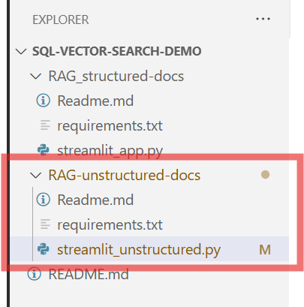

2. Install the requirements
pip install -r requirements.txt

3. Run the command to launch the Streamlit app
streamlit run streamlit_unstructured.py --server.maxUploadSize 500

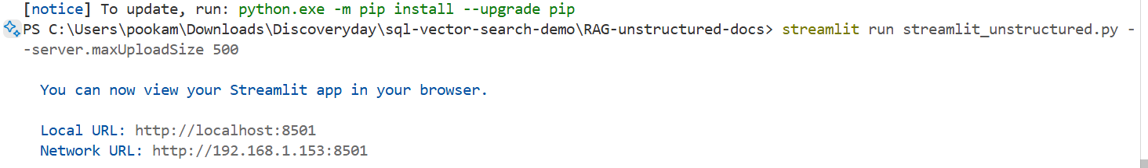
4. Input the configuration strings (Azure SQL & Azure Open AI) just as you did in the previous demonstration. The Azure Open Key and Endpoint will also remain unchanged from before.
If you need to find it again – Go to your resource group & click on the respective resource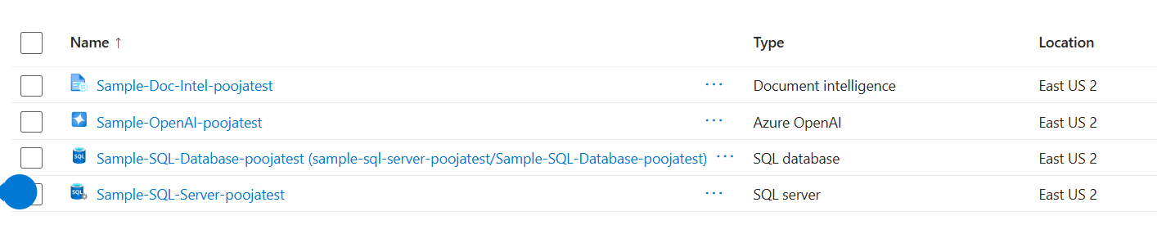
Azure Open AI Key and Endpoint:
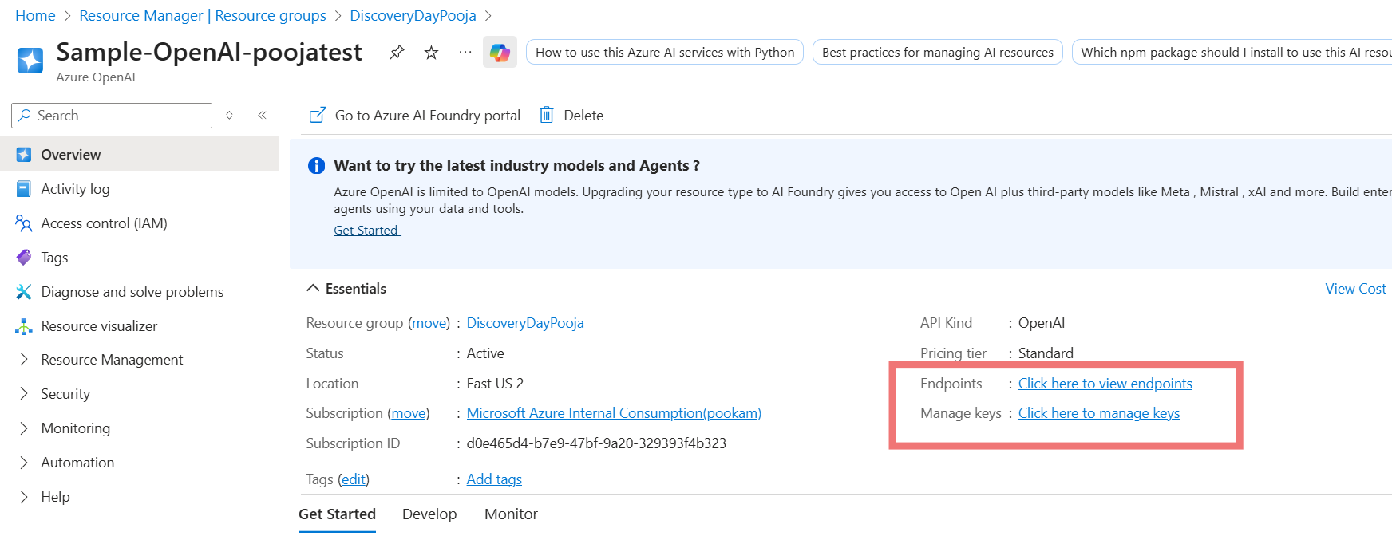

Document Intelligence Key and Endpoint:
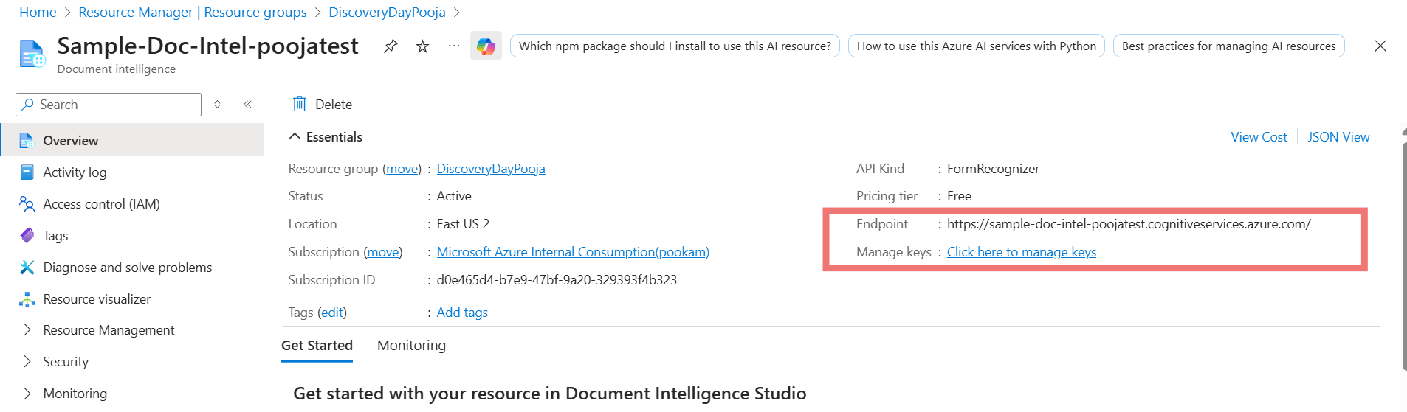
5. Using the App -Create the table for storing the embeddings with the Vector Data Type and Document Chunks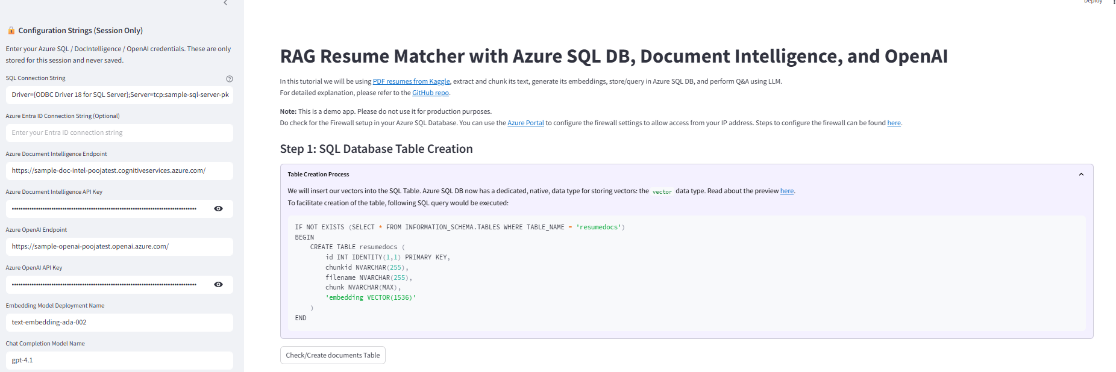
6. Download the Resume Data set from the Repo
For this project, we have included 10 sample resumes in the Repo from the original dataset for testing purposes. These samples are intended to demonstrate the functionality of the application without requiring the full dataset.
The original dataset is available on https://www.kaggle.com/datasets/snehaanbhawal/resume-dataset and contains more than 120 resumes in the Information Technology sector.

Why Azure Document Intelligence?
AI Document Intelligence is an AI service that applies advanced machine learning to extract text, key-value pairs, tables, and structures from documents automatically and accurately. This means you can turn documents into usable data and shift your focus to acting on information rather than compiling it.
Why are we chunking?
When dealing with content that exceeds the embedding limit of our model, we need to break it into smaller pieces. This is because the model that generates embeddings can only handle a certain amount of text at a time.
Here, we divide the extracted text into fixed chunks of 500 tokens. These chunks are later passed to the text-embedding-small model to generate text embeddings, as the model has an input token limit of 8192
This process breaks down resumes into manageable pieces, making them easier to analyze and process. Think of it as turning a giant pizza into bite-sized slices—much easier to handle!

Since we are using a Free Tier of Document Intelligence we may experience Throttling and this process may take a little longer. 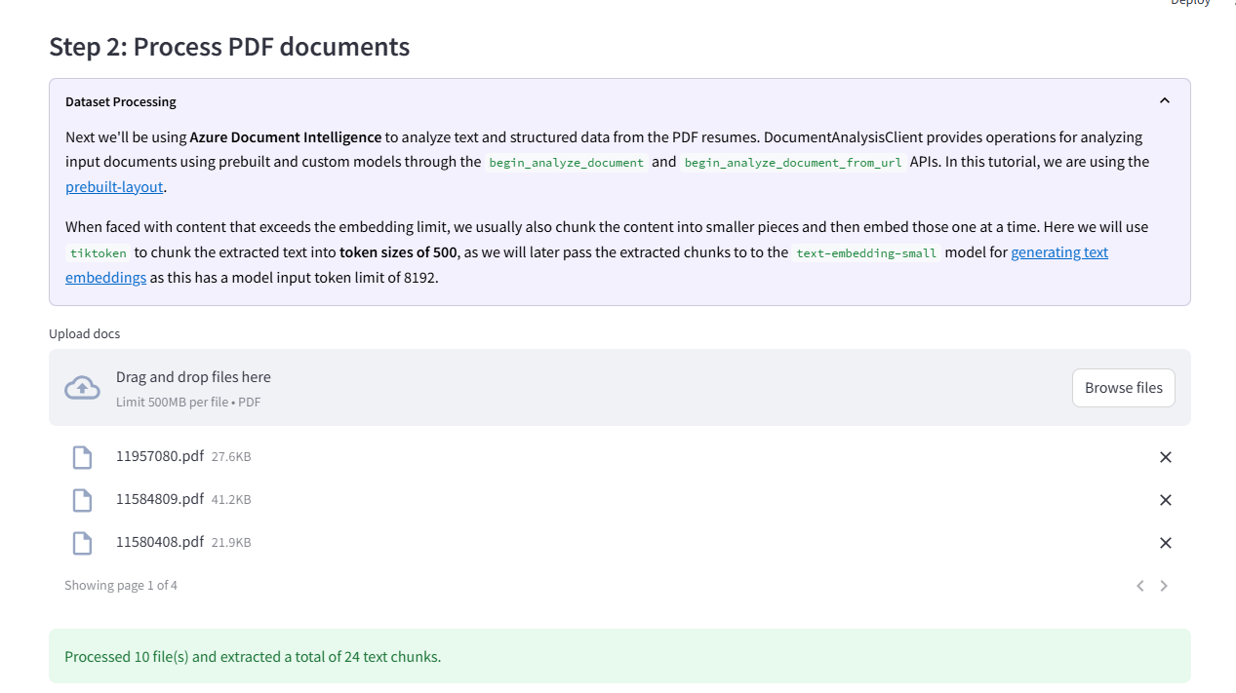
7. Click on Embedding Generation to generate embedding for each chunk & insert this into the SQL DB
Next, we generate embeddings from the chunked content using the Azure OpenAI API. These embeddings are vector representations of the text, capturing the semantic meaning of the content.
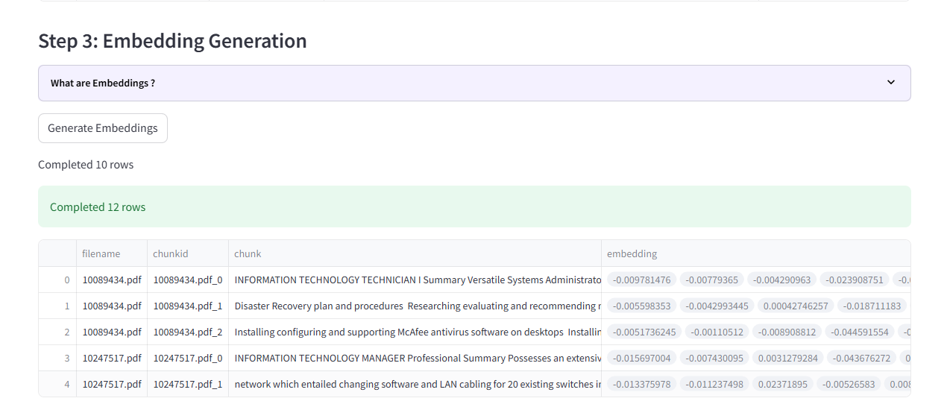
We then store these embeddings in Azure SQL DB using the new Vector data type. This allows us to perform similarity searches using built-in vector functions, enabling us to find the most suitable candidates based on their resumes
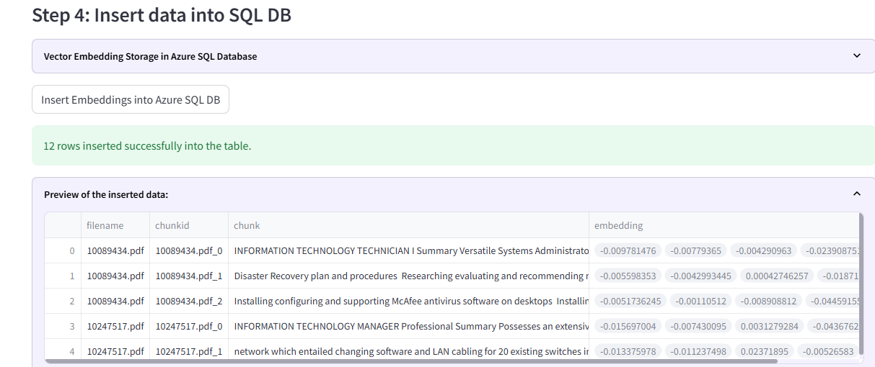

8. We can now perform the Vector Search on this database as we have embedding stored.
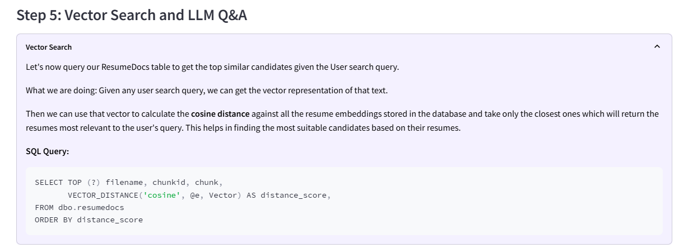
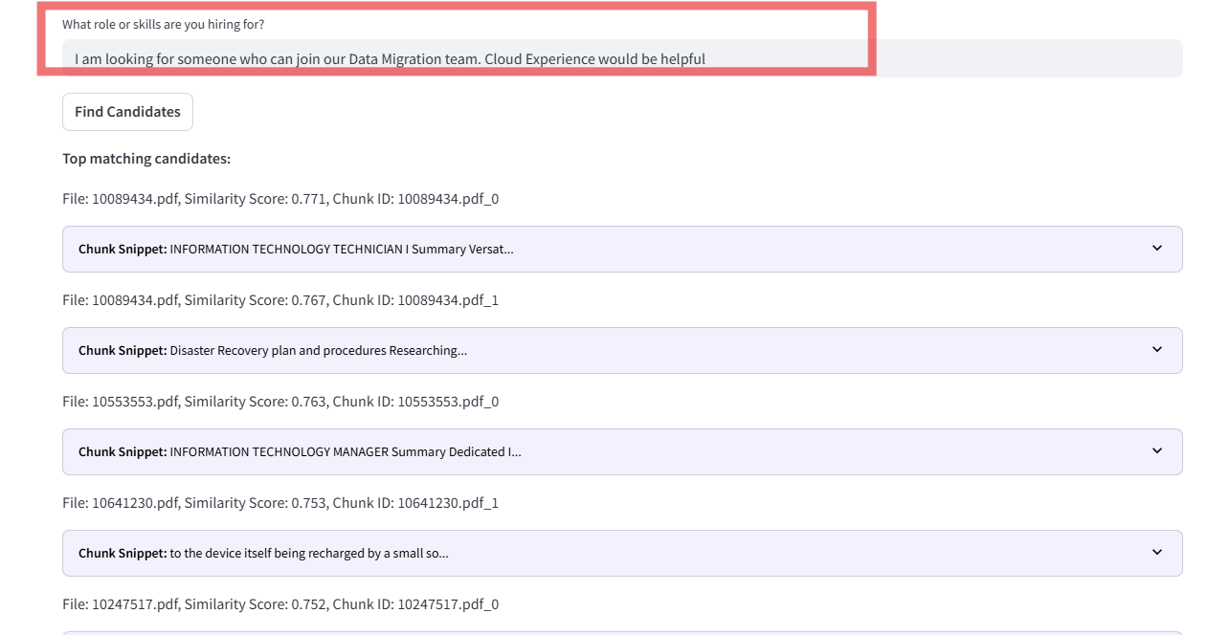
For example: If your search query is focused on project management skills, the embeddings can help find candidates with relevant experience, even if they use different terminology:
Search Query: “project management”
Matched Candidate Skills:
- “Led multiple software development projects”
- “Certified Scrum Master with experience in Agile methodologies”
- “Managed cross-functional teams to deliver projects on time and within budget”
The embeddings capture the essence of “project management” and match it with various related skills and experiences. It’s like having a supercharged recruiter at your fingertips!

9. Augmenting LLM Generation
Finally, we enhance language model generation with the Vector Search results from our Azure SQL Database. By informing a GPT-4.1 chat model with the results of our Vector search, we can provide rich, context-aware answers about candidates based on their resumes.
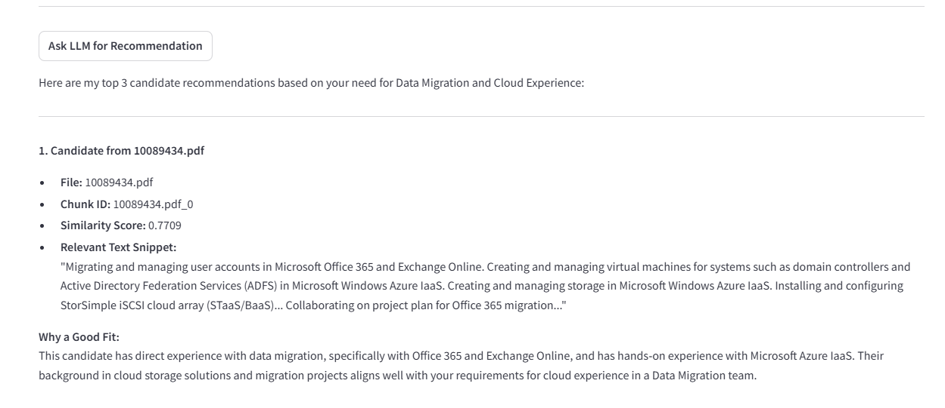
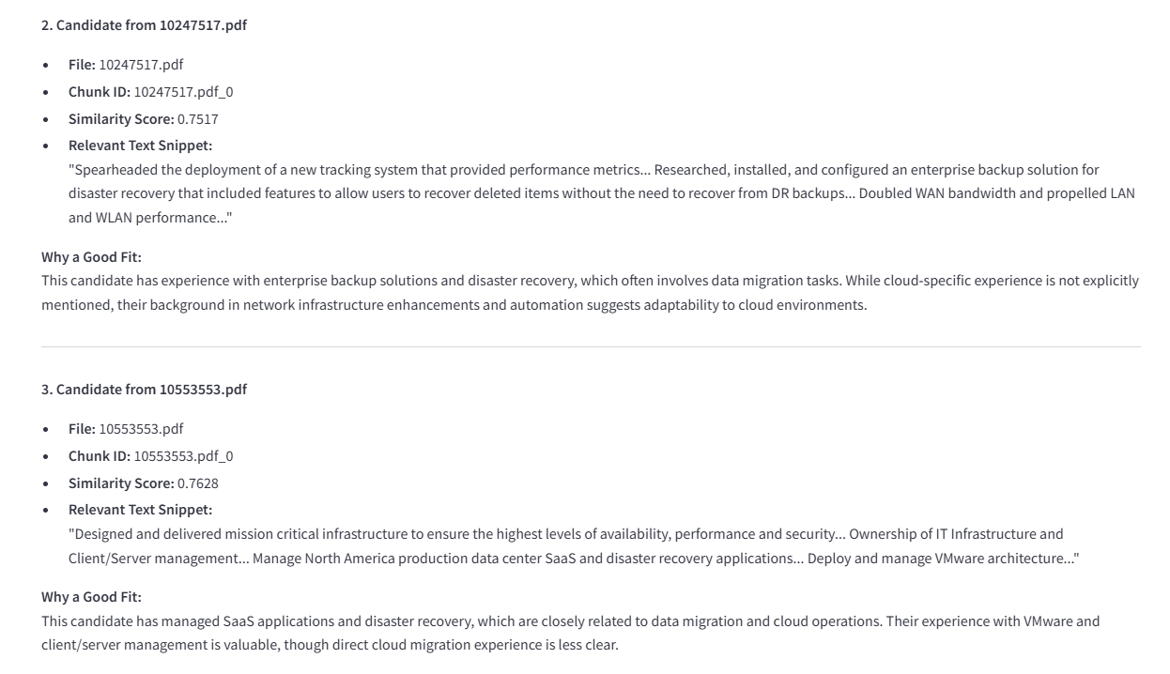

Hence by utilizing Azure SQL DB’s vector capabilities along with the power of Azure Document Intelligence and Azure OpenAI, you can totally transform your hiring game.
No more missing out on the perfect candidate, and your interviews will be more on point than ever. But why stop at resumes? Dive into your own documents—whether they’re project reports, research papers—and uncover hidden gems. This cool approach not only saves you time but also boosts the quality of your recruitment and document analysis. Happy exploring and hiring! 🚀

Clean Up Resources
Clean Up:
When you're finished using these resources, or if you want to start over again with a new free database you can delete the resource group you created, which deletes all the resources within it.
To delete myResourceGroup and all its resources using the Azure portal:
- In the Azure portal, search for and select Resource groups, and then select myResourceGroup from the list.
- On the Resource group page, select Delete resource group.
- Under Type the resource group name, enter myResourceGroup, and then select Delete.

